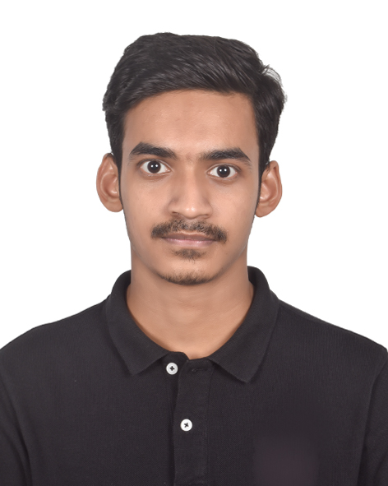
A. F. M. RAFIUL HASSAN
House 219/1 E-1, Road 8/1, Block-D
Banasree, Rampura, Dhaka
01849900880
afmrafiulhassan@gmail.com

Objective: To develop skills through implementing ideas and analyses in Data Security, Designing Innovative Solution and gain hands-on experience to build a successful career in leading tech organizations.

PERSONAL STATEMENT

A motivated Computer Science student passionate about cybersecurity and securing digital systems. Equipped with foundational knowledge in threat analysis, secure coding practices, and tools like Kali Linux and Burp Suite. Certified in cybersecurity fundamentals (CISCO, OPSWAT) and eager to apply classroom learning to real-world challenges. Known for strong analytical thinking, adaptability, and a proactive approach to problem-solving. Committed to continuous learning and contributing to building safer digital environments.

PERSONAL INFORMATION

Name: A. F. M. Rafiul Hassan
Father’s name: Md. Abul Foyez
Mother’s name: Kohinoor Akter
Date of birth: 15th August, 2002
Religion: Islam
Nationality: Bangladeshi
Blood group: B+
Contact number: 01849900880

EDUCATIONAL BACKGROUND

Degree | Institution | Concerned Areas | GPA | Passing year
Bachelor of Science Computer Science & Engineering (CSE) | American International University of Bangladesh (AIUB) | Major: Information Security  Minor: Software Quality Assurance | 3.50 | 2025
Higher Secondary School Certificate(HSC) | Ispahani Public School & College | Science | 5.00 | 2020
Secondary School Certificate(SSC) | Comilla Modern High School, Comilla | Science | 4.94 | 2018
PROJECTS

LALC Connect | HTML, CSS, PHP, JavaScript, MySQL

- Developed a full-stack lawyer-client appointment and case management system with role-based dashboards.
- Enabled clients to book appointments, submit reviews, and manage legal payments.
- Designed lawyer dashboard for handling appointments, tracking case progress, and viewing feedback.
- Implemented relational data structure to manage lawyers, clients, courts, cases, payments, and reviews.
- Ensured responsive UI with consistent theming and dynamic form handling.

ADventure | HTML, CSS, PHP, Javascript, MySQL

- Developed a full-stack advertisement platform integrating businesses, users, and administrators.
- Implemented targeted ad campaigns with real-time performance analytics.
- Designed personalized ads with advanced filtering and search capabilities.
- Built secure user and admin authentication system with password verification against the database.
- Implemented system settings management, ad viewing, wishlist functionality, and feedback submission features.
- Optimized game performance and UI for a smooth user experience.

RELEVANT SKILLS

- Language – C++, Python, R, Shell, HTML, CSS, PHP, JavaScript, Basic SQL, PL/SQL
- Frameworks – Selenium, CIS Control, SOC2
- APIs –SecurityTrails, CloudFlare, Google Safe Browsing API
- Software – Burp Suite, Nmap, Kali Linux, Metasploit, Cyber-security Moitoring Tools, Microsoft (Word, Powerpoint, Excel)
- Database – Oracle, MySQL

INTERPERSONAL SKILLS

- Analytical skill
- Communication skill
- Collaboration skill
- Able to work as an individual, leader or teamwork.
- Outstanding research and presentation exposure with multitasking ability.

CERTIFICATIONS

- Introduction to Critical Infrastructure Protection (CIP) – OPSWAT Academy
- Introduction to Cybersecurity – CISCO
- Masterclass on Cybersecurity – Grameenphone Academy
- Participation on Cyber Security & Social Awareness Program - 2022 – Career Pro BD

EXTRACURRICULAR ACTIVITY

- Founder & President – IPSC Photography Club – (2018 – 2020)
- General Member – AIUB Computer Club – (2023 – 2025)
- Competitor – Jarvis 4.0 – Intra ACC Carnival – (2024)
- Volunteer – AIUB CSFest – 2024 (2024), Cultural Night Program, IPSC – (2020)

LANGAUGE PROFICIENCY

- Bengali
- English
- Hindi

HOBBIES AND INTERESTS

- Photography
- Travelling
- Reading

REFERENCES

Zubair Azami Badhon  Chief Engineer  Samsung R&D Institute Bangladesh  Email: zubair.azami@samsung.com | Dr. Abdus Salam  Associate Professor  Department of Computer Science  American International University - Bangladesh  Email: abdus.salam@aiub.edu

